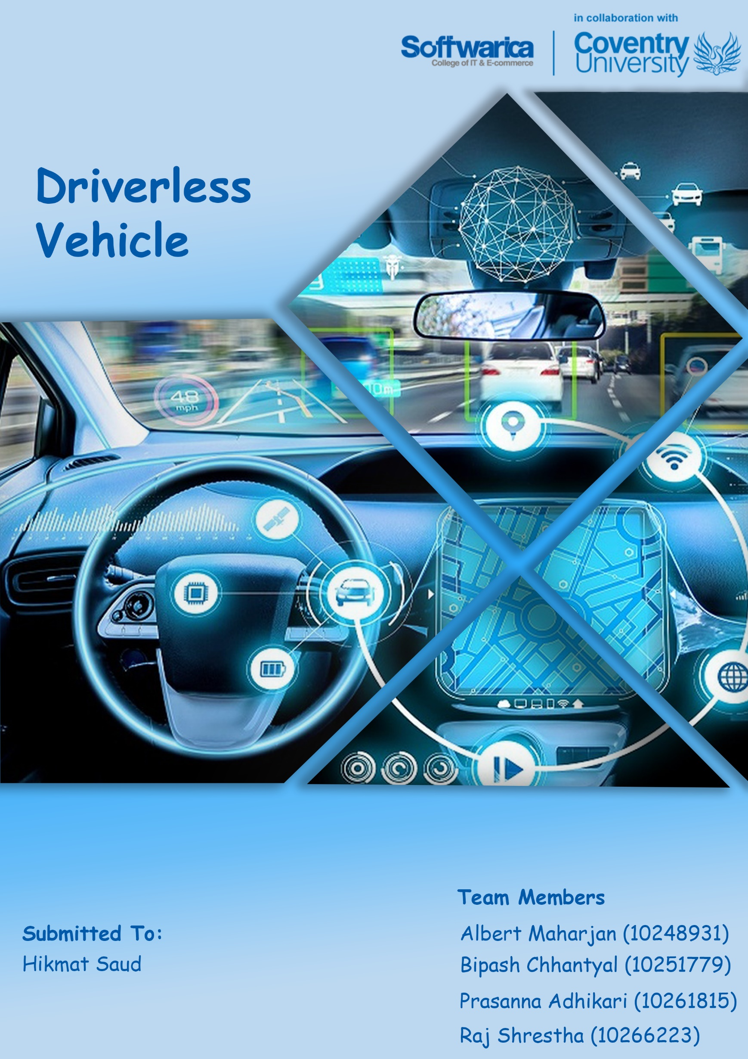

Table of Contents

Introduction 1

Aim & Objectives 2

Aim 2

Objectives 2

Justification 3

Solution 4

Literature Review: 5

Tesla 5

Starship Technologies autonomous robot delivery service 6

SkySquirrel Technologies Agricultural Drones 7

Tools and technologies 8

Hardware 8

Arduino Mega 8

Single Channel Relay 5v (1pc) 9

Dual Channel Relay 5v (1pc) 10

12v 30Ah Two Channel Relay (2 pc) 11

24v Motor (1pc) 12

48v Rickshaw Motor (1pc) 13

12v Battery (4pc) 14

12v Battery (1pc) 15

Potentiometer (1pc) 16

Depth Camera D435 (2pc) 17

Logitech 1080p camera (1pc) 18

Software 19

Arduino IDE with C 19

Python 19

Opencv2 19

TensorFlow 20

Algorithm 21

Mobile net SSD 21

Custom path finding from cone 22

Depth-align 22

The Build 24

Circuit Diagram 24

Working Mechanism 25

Risk Matrix: 26

Gantt Chart 27

Privacy and Ethical consideration 28

Testing 28

Solved issues after testing 28

Issues that still remains 29

Future work: 29

Conclusion 29

References 30

Appendix 32

Figure 1: Autonomous Vehicles 1

Figure 2: Aims and Objective 2

Figure 3: Road accident 3

Figure 4: Driverless Vehicle 4

Figure 5: Software implementation and working mechanism on tesla 5

Figure 6: Autonomous delivery Service 6

Figure 7: Autonomous drone for agricultural purpose 7

Figure 8:Arduino Mega 8

Figure 9:Arduino Relay 9

Figure 10:Dual channel Arduino Relay 10

Figure 11:12v 30Ah 2 channel Relay 11

Figure 12:24V 250 Watt DC Motor 12

Figure 13:48V 1000Watt DC Motor 13

Figure 14:Acidic 12V Battery 14

Figure 15:12V 18Ah Exide 15

Figure 16:Potentiometer 16

Figure 17:Depth Sensing Camera 17

Figure 18:USB HDMI Logitech camera 18

Figure 19:Arduino Software IDE 19

Figure 20:Python Language 19

Figure 21:Python image processing library OpenCV 20

Figure 22:Python Object Detection Library TensorFlow 20

Figure 23:Mobile Net SSD Algorithm 21

Figure 24:Object detection camera view 22

Figure 25:Depth align 23

Figure 26:Circuit Diagram 24

Figure 27:Flow chart showing the working mechanism of driverless car 25

Figure 28:Risk Matrix 26

Figure 29: Gantt chart showing the tasks performed to complete the project 27

Figure 30:Testing of vehicle movement to the defined destination 28

Figure 31: Arduino Code 32

Figure 32: Manual Python source 37

Figure 33: Behavioural Cloning code 39

# Introduction

Vehicles have changed our life and way we live. Self-Driving vehicles are going to change the mobility and disturb automobile industry. Self-Driving vehicles uses different sensors, radars, cameras, artificial intelligence to sense the environment in order to run without any human participation. (*Accelerating Autonomous Vehicle Technology* 2021) Autonomous vehicle can bring various advantages to society. It makes driving more easier and faster. Different sensors used in autonomous like radar, lidar and camera help to detect obstacles in its way and stop vehicle automatically in case of emergency. This makes autonomous vehicle lot safer. Autonomous vehicle reduces traffic cognitions like stop-and-go traffic. Autonomous vehicle enhance independence for physically disables people, old people and people who cannot drive. They can go wherever they want and live their life as they want with highly automated vehicle.

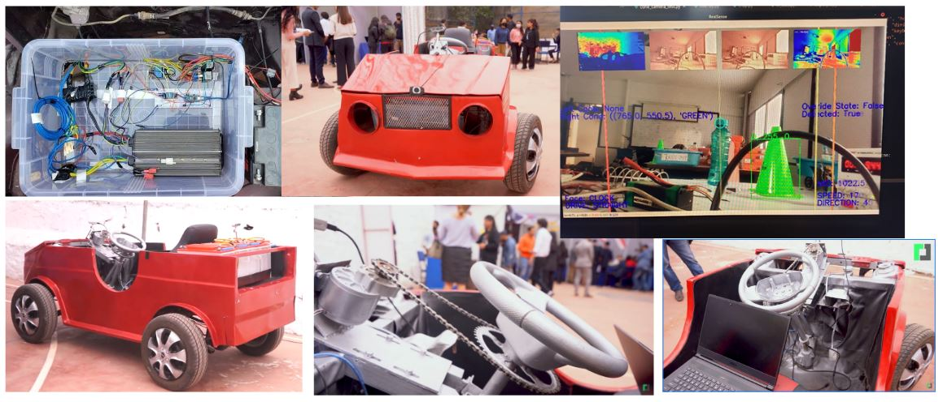

Figure : Autonomous Vehicles

Our team have developed driverless vehicle with obstacle avoidance system which can drive itself and improve driving experience. This system is built in real four-wheeler vehicle. Camera is used to detect obstacles. This vehicle ensure that it makes safe distance from the obstacles collision it detects. If the object is near and the vehicle is about to collide then it will stop automatically which makes it lot safer. Artificial intelligence to move on the path it has already been through once is also implemented in this vehicle. It impersonators the task as per the saved data and recaches the destination.

# Aim & Objectives

## Aim

Develop a driverless vehicle that can drive itself without human interference and can impersonate human task through machine learning.

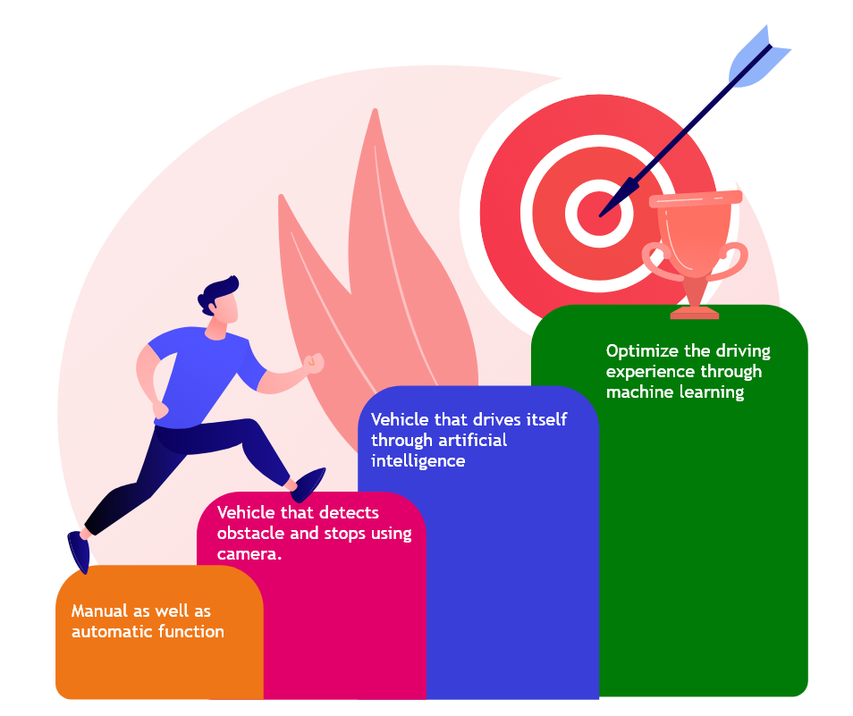

Figure : Aims and Objective

## Objectives

* Driverless car that can be controlled through remote connection
* Detects obstacle by using camera
* Impersonate human task
* Detects traffic light, lanes, humans, animals, etc and take decision
* Discover its path to reach the destination and executes task through machine learning

Justification

Vehicle has become primary source of mobility. They should be comfortable, safer and be able to reach in destination at less amount of time. While driving a normal vehicle, a person has to face lots of challenges. After a long hard day, everyone wants to reach home faster while relaxing in their vehicle.

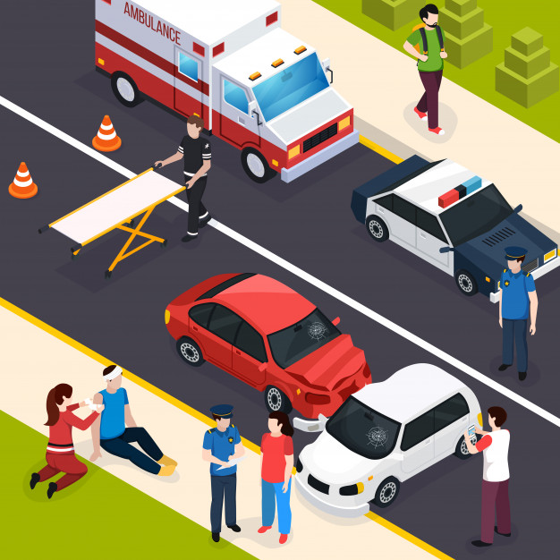

Figure : Road accident

But driving normal vehicle, a person has to be always aware of the road and cannot take rest. A long ride is even hard to travel. Person cannot relax in the vehicle because they have to keep an eye on the road and always be aware of their surrounding which causes fatigue to drivers.

## Solution

Driverless vehicle with collision avoidance system is developed. This vehicle runs automatically without any human in the steering. Obstacle detection and collision avoidance system is added in this vehicle. This system makes driving more easier, safer and faster.

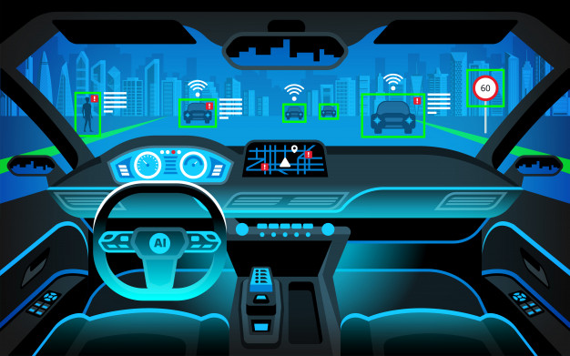

Figure : Driverless Vehicle

This vehicle provide comfort, safer and easier to drivers. Sensor used in this vehicle detects any obstacle near the vehicle and if the obstacle is close to it, it will automatically stop. Driver can relax while driving this vehicle. Collision avoidance system make it easy, relaxing and safer to drive the vehicle. Artificial intelligence to recognise the path it has already been through once is also implemented in this vehicle. The technology improves the driving experience. Manual control system is also added in case to apply emergency break in case the system malfunction or does not detect obstacle.

# Literature Review:

## Tesla

Tesla has modernized the automobile industry enhancing the autopilot. Today, all the tesla car comes with advanced hardware that is capable of providing autopilot features which makes driving safer and less stressful, possibly soon full self-driving capability as its software are so designed that it improves functionality over time. Currently, autopilot provides features like traffic-aware cruise control, autosteer, auto lane change, auto park, smart summon (moving car in and out of a tight space), and traffic and stop sign controls. For the safety measures, the tesla autopilot hardware and software system made possible features like automatic emergency braking, front and side collision warning, obstacle aware acceleration, lane departure avoidance, and blind-spot monitoring. These features are designed to assist the drivers, it might not be able to respond in every situation, therefore driver supervision is necessary to be in control of the car all the time.

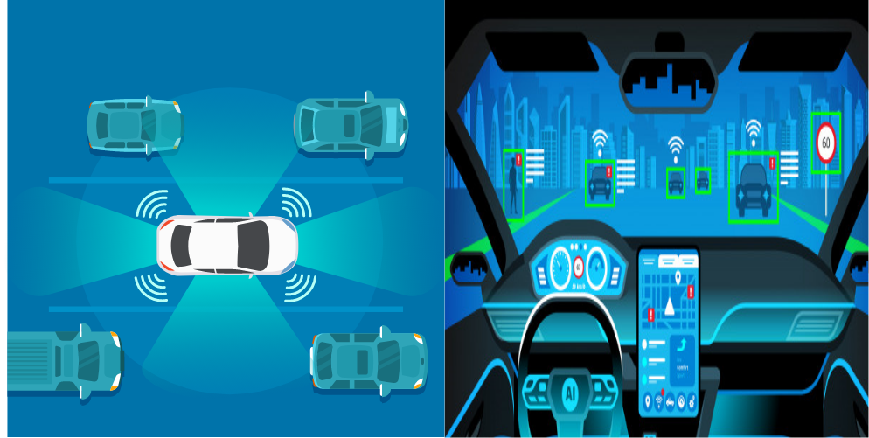

Figure : Software implementation and working mechanism on tesla

Hardware used in Tesla’s self-driving capability are:

Eight external cameras that covers 360 degrees of visibility at up to 250 meters of range. A radar with enhanced processing which is able to see through heavy rain, fog, or dust. Twelve ultrasonic sensors for the object detection and a powerful onboard computer adds an extra layer of protection to your journey.

(*Support* 2021)

## Starship Technologies autonomous robot delivery service

Starship Technologies is the world’s leading autonomous delivery service provider. Today, they have completed over one million autonomous deliveries. Starship technology make local delivery quicker, smarter, and more cost-effective by combining mobile technology, autonomous robots, and partnerships with stores and restaurants. The process of this autonomous start after the customer request via a mobile app and is directly delivered from stores as robots’ entire journey and location can be monitored on smartphone. The self-driving delivery robot carry items within a 4-mile (6km) radium. After arriving the location, recipient will receive a notification and only be opened with their smartphone app. (*A New Kind Of Business.* 2021)

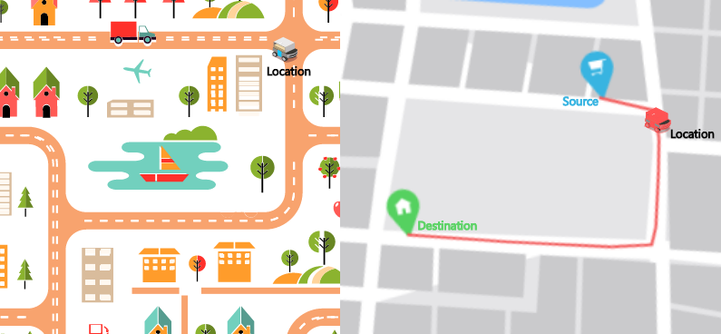

Figure : Autonomous delivery Service

Starship technology uses sets of hardware that is radars, a multitude of cameras and ultrasonics to sense the world. Machine learning through Neural Network is used to make robot safe driving decision after sensing an object. It enables robots to be secure on road crossings by avoiding obstacles such as vehicles, as well as on sidewalks by understanding all of the possible paths that humans and other obstacles can take. (*How Neural Networks Power Robots At Starship* 2021)

## SkySquirrel Technologies Agricultural Drones

Drone technology, one of the phenomenal innovations that have transformed human’s lives and the way of doing business. Agricultural Industry (Modern farming) seems to be transformed by including drone technology. Using high-tech drones allows farmers to increase efficiency in the farming process. (Problems 2021)

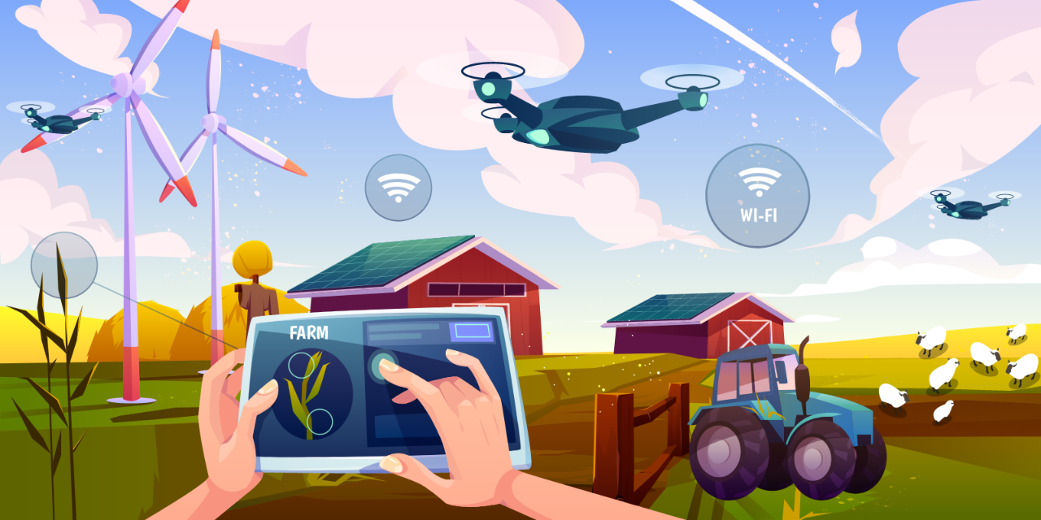

Figure : Autonomous drone for agricultural purpose

SkySquirrel Technologies Inc, a Canadian start-up that develops drones that monitor and analyse crop health using imaging technology. Their mission is to provide framers data that will help to increase the quality and efficiency of the crop and reduces crop losses from the disease at commercial vineyards. The drone first collects data from the fields which is then analysed by experts. The company uses algorithms that analyse the images capture and provides comprehensive reports on the farm’s current health. Therefore, it assists farmers in detecting pests and bacteria, as well as the timely application of pest control and other methods to improve the farm's health. (*F6S* 2021)

# Tools and technologies

## Hardware

### Arduino Mega

Arduino mega is used to control the microservice of the car. The steering rotation trigger, throttle forward and reverse trigger, speed signal and reading of steering potentiometer is processed by Arduino mega in this project.

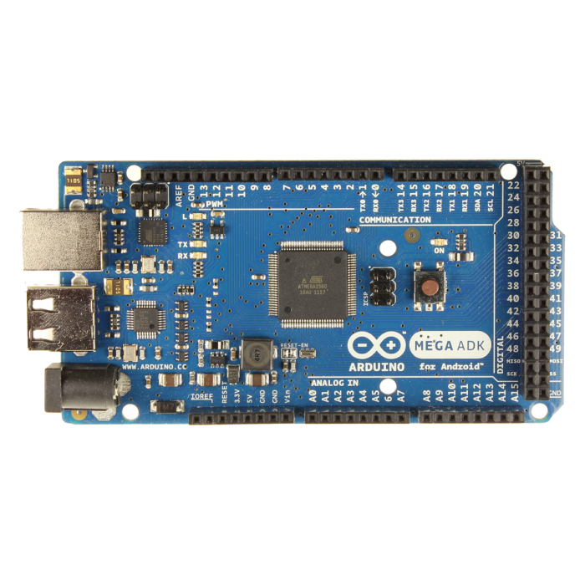

Figure 8:Arduino Mega

Specifications:

1. ATmega2560 microprocessor
2. 5v operating voltage
3. 54 I/O pins (15 PWM)
4. 256KB flash memory
5. 8kb SRAM
6. 16 MHz clock speed

### Single Channel Relay 5v (1pc)

1 single channel relay is used to trigger the throttle forward or backwards.

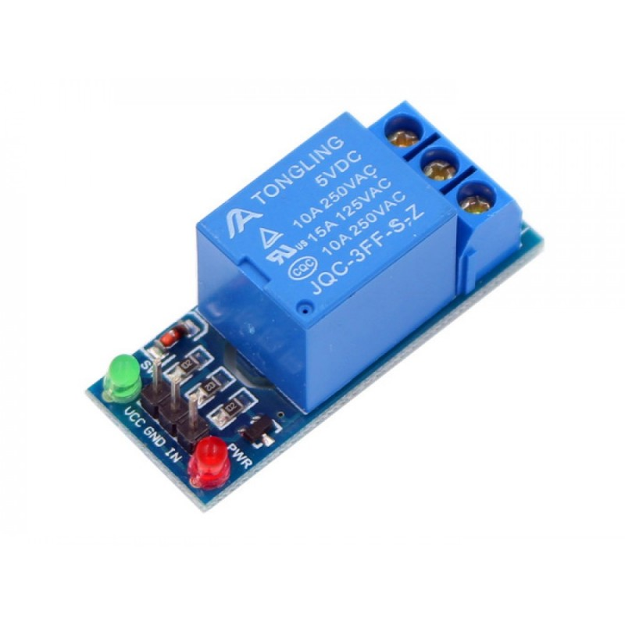

Figure :Arduino Relay

Specifications:

1. 3.75V-6V
2. Active current 70mA
3. Maximum contact voltage 250VAC
4. Maximum current 10A

### Dual Channel Relay 5v (1pc)

2 Dual channel relays are used to trigger another 12v relay to control the positive or negative current flow of the steering motors.

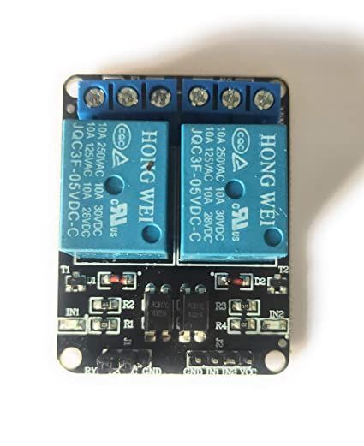

Figure :Dual channel Arduino Relay

Specifications:

1. Supply voltage 3.75V-6V
2. Trigger current 5mA
3. Current active (both) 140mA
4. Maximum contact voltage 250VAC
5. Maximum current 10A

### 12v 30Ah Two Channel Relay (2 pc)

2 12v relays are used to trigger the positive, negative or neutral current of the 24v motor used for steering.

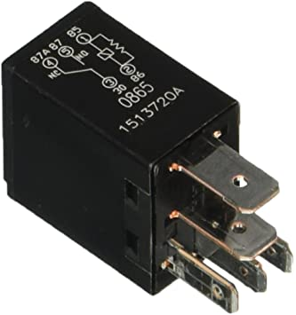

Figure :12v 30Ah 2 channel Relay

Specifications:

1. Supply voltage 12V
2. Current 24A-40A

### 24v Motor (1pc)

1 24v motor is used to turn the steering attached to the steering wheel with bicycle chain.

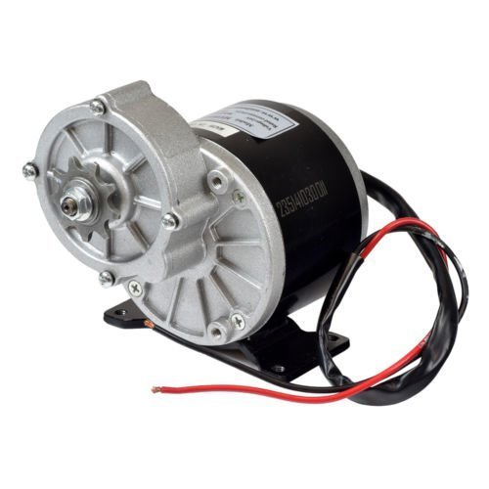

Figure :24V 250 Watt DC Motor

Specifications:

1. Maximum supply voltage 24V
2. Speed 400 RPM
3. Wattage 250W (0.33 Horsepower)
4. Torque: 22
5. 9 Tooth Sprocket for 1/2" x 1/8" Pitch Chain

### 48v Rickshaw Motor (1pc)

1 48V rickshaw motor is used to rotate the differential of the car.

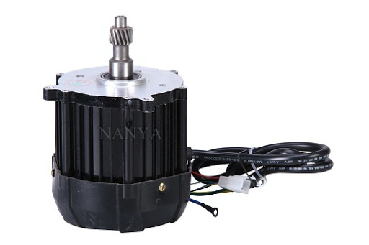

Figure :48V 1000Watt DC Motor

Specifications:

1. Maximum supply voltage 48V
2. Power 1000W
3. Speed 2000-6000 RPM
4. BLDC type

### 12v Battery (4pc)

4 12v battery is used to supply power for the differential motor of the car.

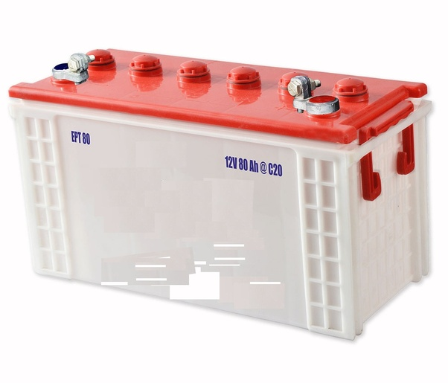

Figure :Acidic 12V Battery

Specifications:

1. 12v power supply
2. 80ah current capacity

### 12v Battery (1pc)

1 12v battery is placed independently for the motor control of the steering.

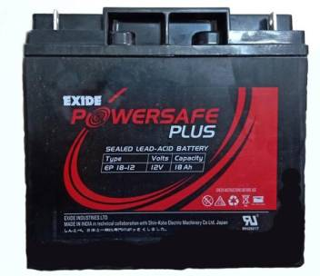

Figure :12V 18Ah Exide

Specifications:

1. EP 18-12 type
2. 12 voltage power supply
3. 18 Ah current capacity

### Potentiometer (1pc)

1 potentiometer is used to calculate the angle of the steering. It is attached to piston holder which rotates circularly.

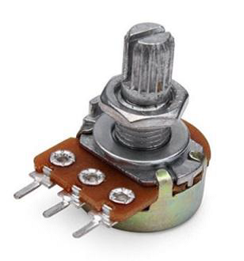

Figure :Potentiometer

Specifications:

1. 500 Ohm~1M Ohm potentiometer potential
2. 1A at AC/DC 125V rated power
3. 300-degree rotation travel
4. S.P.S.T switch circuit

### Depth Camera D435 (2pc)

2 depth cameras are used on both front and back of the car to detect the objects and collision for up to 2m far.

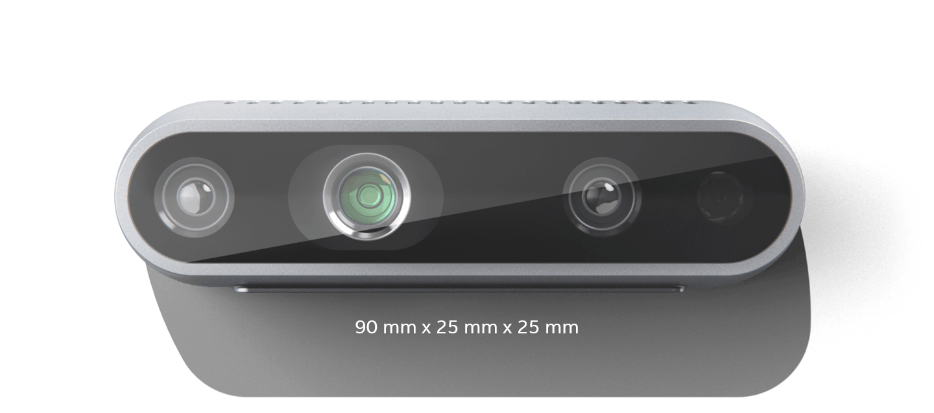

Figure :Depth Sensing Camera

Specification:

1. Global Shutter, 3μm × 3μm pixel size
2. Active IR Stereo
3. 86° × 57° (±3°) Depth FOV
4. 28 cm depth distance
5. 64° × 41° × 77° (± 3°) RGB FOV

### Logitech 1080p camera (1pc)

The Logitech camera is placed at the front of the car, below the bonnet of a car. This expands the viewing scope of the application and is used to detecting the cones and/or lanes in future versions.

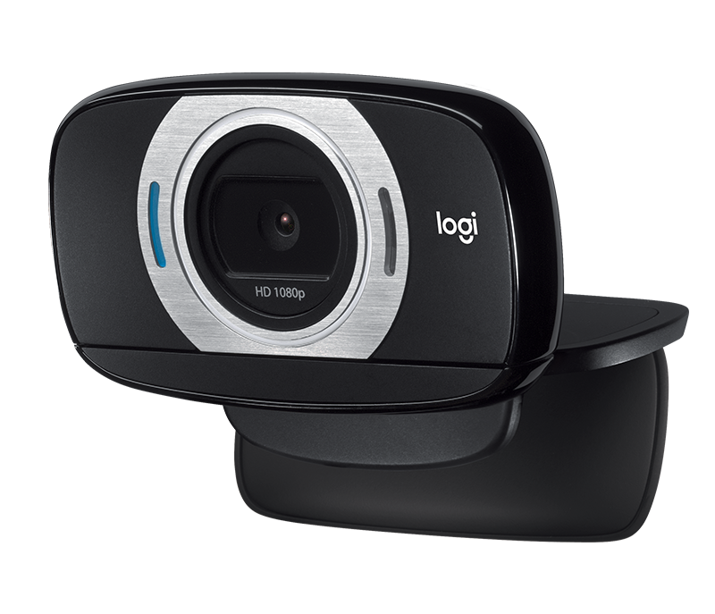

Figure :USB HDMI Logitech camera

Specifications:

1. 8.0 MP still-image resolution
2. CMOS image sensor
3. Enabled auto focus

## Software

### Arduino IDE with C

Open-source Arduino IDE is used to push the sketch to Arduino mega. The program is used to program the Arduino device to control the microservice of the car is written in C.



Figure :Arduino Software IDE

### Python

Python is used as the main programming language to link image processing and microcontroller. The communication to Arduino is done with serial communication with pySerial library. The depth camera is processed with intel’s official source code using pyrealsense2.



Figure :Python Language

### Opencv2

OpenCV (Open-Source Computer Vision Library); an open-source computer vision and machine learning software library is used to handle the camera frames of the python software. It processes two depth cameras and one 1080p RGB camera simultaneously. The frames of camera feed are converted into array of colour pixel values, which then is used to apply logic by accessing and augmenting the pixel values of the frame. (*About - Opencv* 2021)



Figure :Python image processing library OpenCV

### TensorFlow

TensorFlow; an end-to-end platform to build and deploy machine learning models. Models are trained with input, multiple layers and output. In this project, it is used for object detection like cones, people, car, bikes, etc.

Figure :Python Object Detection Library TensorFlow

The layers of the model extract the feature of the input with weights and biases according to the features. The model then can predict the object based on the features given into new input. (*Why Tensorflow* 2021)

## Algorithm

### Mobile net SSD

The Mobile Net network architecture is a special class of convolutional neural models that are built using depth-wise separable convolutions and are therefore more lightweight in terms of their parameter count and computational complexity. (*Object Detection With SSD And Mobilenet* 2021)

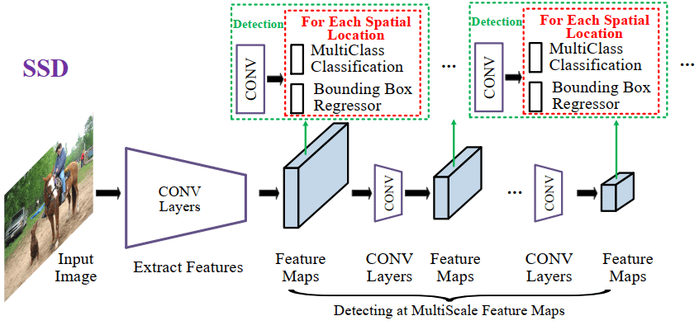

Figure :Mobile Net SSD Algorithm

Single Shot Detector (SSD) is a method for detecting objects in images using a single deep neural network. The SSD approach discretises the output space of bounding boxes into a set of default boxes over different aspect ratios. After discretising, the method scales per feature map location. The Single Shot Detector network combines predictions from multiple feature maps with different resolutions to naturally handle objects of various sizes. SSD excludes the proposal generation and subsequent pixel or feature resampling stages and encapsulates all computation in a single network. It is easy to train and as well as easy to integrate into systems that require a detection component using low resources. (Choudhury et al. 2021)

The integration of Mobile Net into the SSD framework forms one of the core aspects of mobile and faster object detection platform.

### Custom path finding from cone

Once the cone detecting model is trained and loaded, the custom written algorithm from our team, looks for two cones at a time of process. The region of interest is 450 offsets for each side from the middle of the frame.

If the frame has orange cone inside the ROI, the steering commands for going right is triggered. The angle of steering and speed of the throttle is proportional to the distance of the bounding lines of ROI. And if the frame has green cone inside the ROI the actions are reversed. If 2 same-coloured cones are detected, the steering angle is either hard right or hard left.

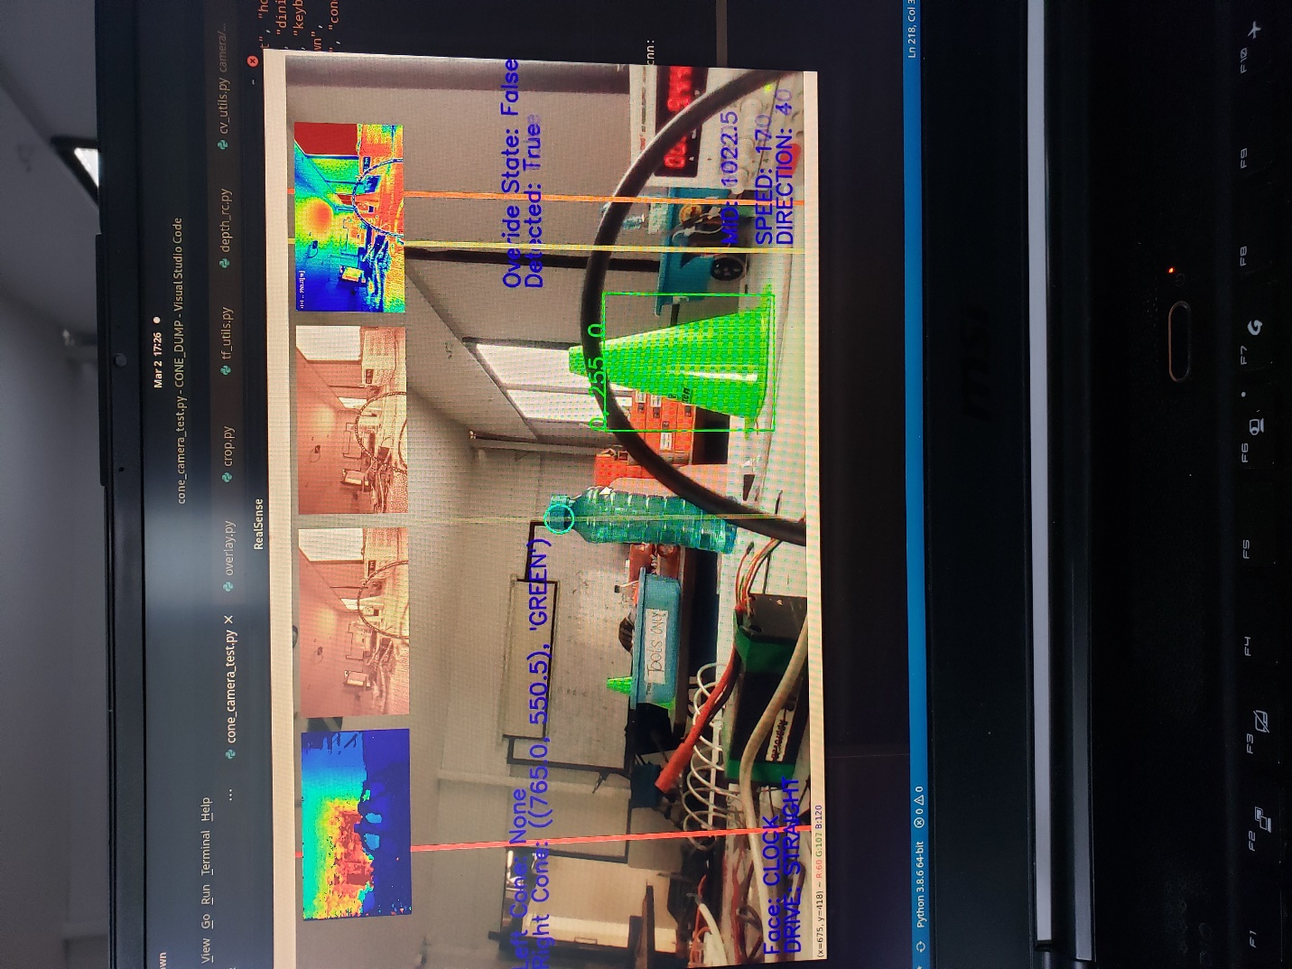

Figure :Object detection camera view

If cones are out of the bounding box, the car goes on a path with previous steering angle and throttle.

### Depth-align

Depth aligning is a process of eliminating the camera feeds from the given distance while capturing the inner distanced feed. The frame is normal up to a given distance while static colour is defined after the distance. The process is further upgraded to classify 2 colour, black for outer bound and white for inner bound of the distance. If certain percentage of white colour are present in the frame, there is a collision in front of the camera.

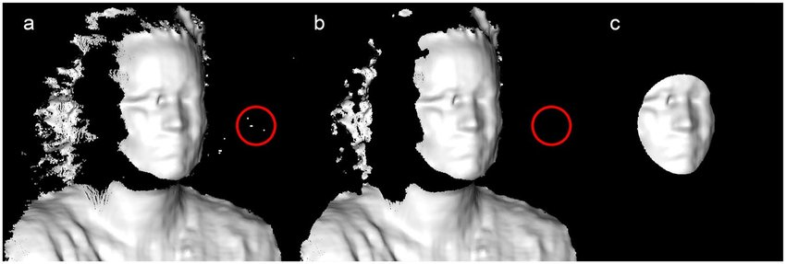

Figure :Depth align

In this project the minimum distance for collision detection is specified to 1.5m and the percentage of collision in white colour is 15%.

# The Build

## Circuit Diagram

RUN .PY SCRIPT

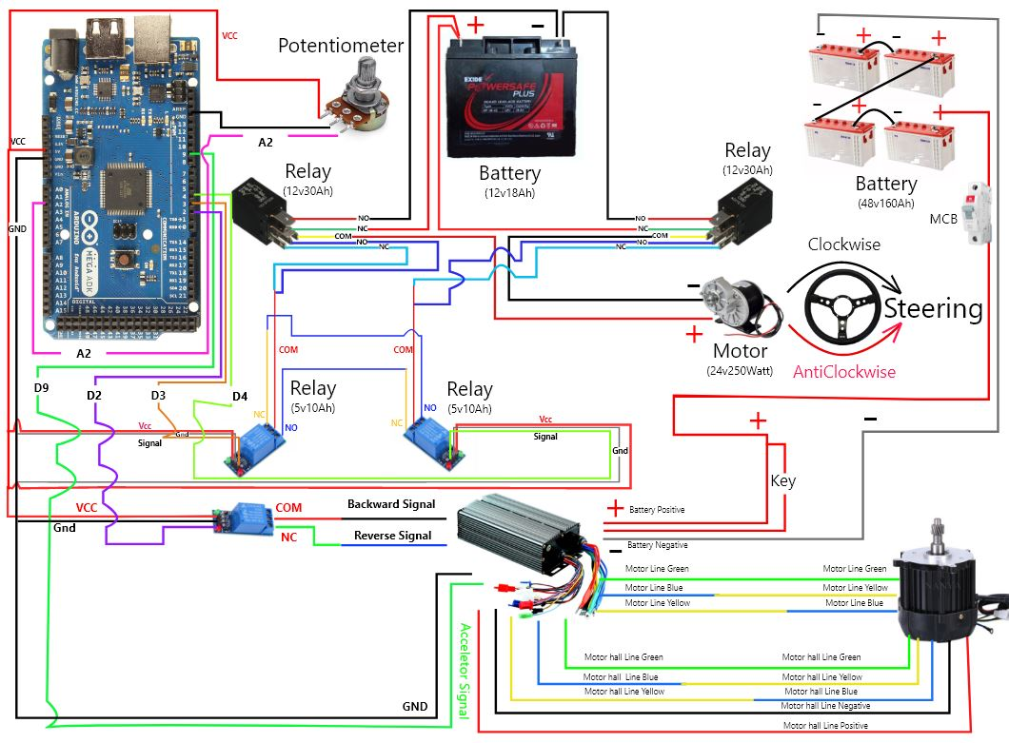

1000Watt

48V Motor

Figure :Circuit Diagram

* MCB switch is turned on to start the connection between motor controller, motor and Battery,
* USB connection is made between laptop and Arduino mega to perform serial communication.
* Python script is executed to test the vehicle.
* Steering movement is calibrated as per the potentiometer value to turn left and right.
* Motor forward and backward movement is calibrated by switching of relay.
* After calibration meets the standard another python script is executed to make it driverless car.

## Working Mechanism

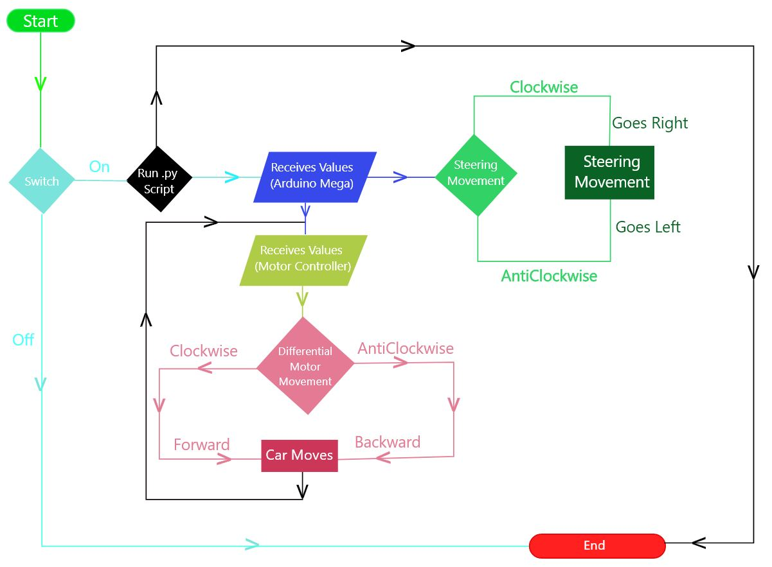

Figure :Flow chart showing the working mechanism of driverless car

MCB is turned on to give power to motor controller and motor. Python Calibration script is executed to calibrate and check the vehicle left, right, backward and forward movement. Arduino-Mega receives the signal from the script and passes to the motor controller and steering motor. Then car starts to move as per the command given from python script. After the calibration is completed another python script is executed where the car can be controlled remotely from anywhere and can mimic the task performed by human.

# Risk Matrix:

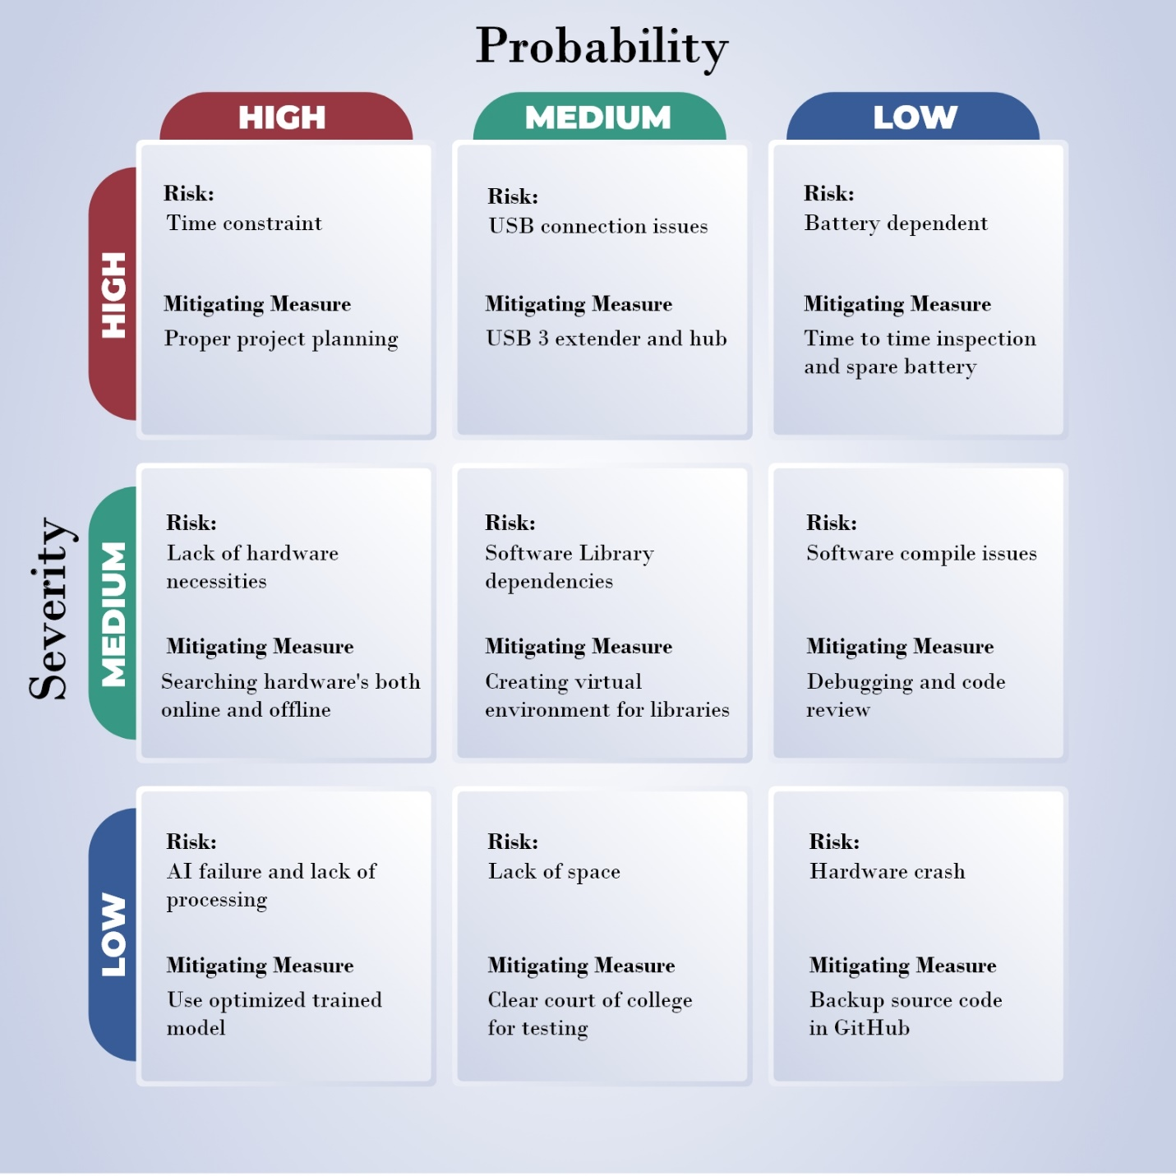

Figure :Risk Matrix

# Gantt Chart

Gantt chart is a type of bar chart which helps to illustrate the project schedule, time and tasks performed to complete the project. It shows the full overview of activities carried out on the project. The illustrative diagram makes shape of project on the mind of the viewer through this Gantt chart.

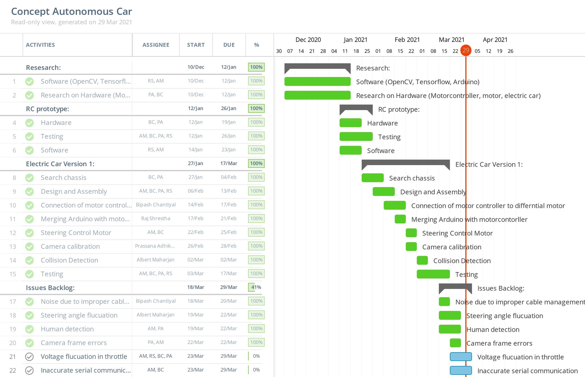

Figure 29: Gantt chart showing the tasks performed to complete the project

The project autonomous car started on the beginning of December. Research on hardware and software were given much time. Maximum task was completed on scheduled time but some of them was not completed due to some issues. Then it was backed up again by spending more time. Some problem still persists but project has been completed on the given time frame with the help of this tool. It helped us to keep track of time and maintain our schedule. The above image shows the details of all the tasks and time spend to complete this project.

# Privacy and Ethical consideration

Many materials like past research paper, books, journals and project ideas were used to make the project successful. These materials were well acknowledged and cited. Huge amount of data was collected using different sensors. The collected data are used to operate driverless vehicle successfully. The project is for educational purpose so only required data were collected while maintaining data privacy and security.

Petroleum vehicle produces mass amount of pollution, since it’s an electric vehicle it is environment friendly and does not affect air. Its battery is rechargeable so there are no expenses as like other vehicle. It is cheap and cost effective for all the people. Most of the task are operated automatically so there is no chance of mistakes as like human error while driving. The software part is beneficial for other devices such as drone, cranes, bus, robot, industries machine, etc. Everything was considered ethically without harming the other factor.

# Testing

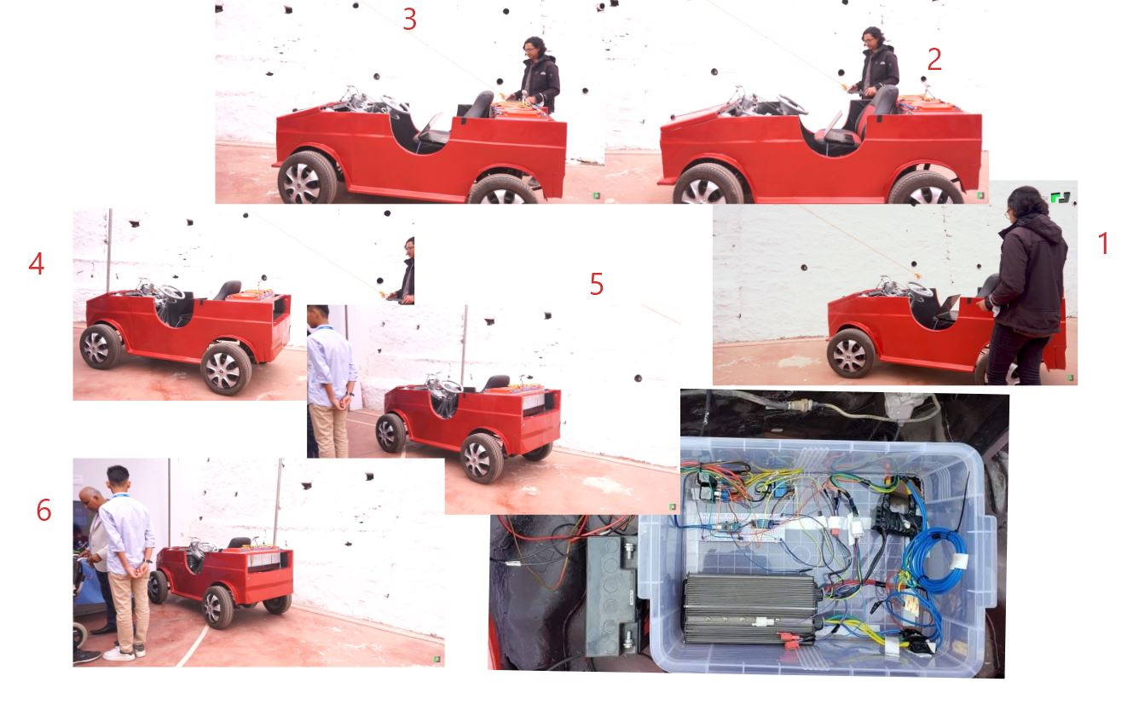

Figure :Testing of vehicle movement to the defined destination

The demonstration and explanation of the project is available on the link below: -

<https://www.youtube.com/watch?v=IBTrBeLULDw&t=1s>

### Solved issues after testing

* Noises were created due to the high ampere wires on same place. It was solved by exiting the wires from different places.
* 12V 10 Ampere dc motor was used for Steering movement but it failed so next 24V DC motor with 250Watt was used to make it work.
* For clockwise and anticlockwise movement 12V relay with 10 Ampere was used but due to the current flow fluctuation it raised up to 18Ampere so, another 12V 30Ampere was used to solve the issue.

### Issues that still remains

* Acceleration signal got fluctuation while transferring its signal value to motor controller so to smooth the signal LM398 was used to make it better but is not the perfect solution and has fluctuation till now.
* While executing python script it sometimes fails to read the value of acceleration

# Future work:

* Implementing Voice Enable Technology (Alexa).
* Lane detection
* Improving AI Algorithm
* Adding an Electric Braking System.
* Improving chassis.
* Transferring system developed to another vehicles.

# Conclusion

The project was completed with the group of four members. Everyone had their role and responsibility to complete the project. Each and every problem was coordinated and discussed to find the solution. Car was successfully controlled remotely and it impersonated the performed task by us. There were some glitches on the impersonate action which needs more optimization to solve it. This will be solved on the later version. With the defined timeframe and objective, we were able to control the car remotely, impersonate the task, detect the cones, detect the person and collisions.

# References

*Road Traffic Injuries* (2021) available from <https://www.who.int/news-room/fact-sheets/detail/road-traffic-injuries> [21 March 2021]

*Road Traffic Injuries And Deaths—A Global Problem* (2021) available from <https://www.cdc.gov/injury/features/global-road-safety/index.html#:~:text=Each%20year%2C%201.35%20million%20people,on%20roadways%20around%20the%20world.&text=Every%20day%2C%20almost%203%2C700%20people,bicycles%2C%20trucks%2C%20or%20pedestrians.> [22 March 2021]

*Accelerating Autonomous Vehicle Technology* (2021) available from <https://spectrum.ieee.org/transportation/self-driving/accelerating-autonomous-vehicle-technology> [22 March 2021]

*10 Advantages Of Autonomous Vehicles | Its digest* (2021) available from <https://www.itsdigest.com/10-advantages-autonomous-vehicles> [23 March 2021]

*Support* (2021) available from <https://www.tesla.com/support/autopilot#:~:text=Built%20on%20a%20deep%20neural,alone%20would%20not%20otherwise%20have.> [28 March 2021]

*A New Kind Of Business.* (2021) available from <https://www.starship.xyz/business/> [28 March 2021]

*How Neural Networks Power Robots At Starship* (2021) available from <https://medium.com/starshiptechnologies/how-neural-networks-power-robots-at-starship-3262cd317ec0> [28 March 2021]

Problems, A. (2021) *AI In Agriculture | Application Of Artificial Intelligence In Agriculture* [online] available from <https://www.analyticsvidhya.com/blog/2020/11/artificial-intelligence-in-agriculture-using-modern-day-ai-to-solve-traditional-farming-problems/> [29 March 2021]

*F6S* (2021) available from <https://www.f6s.com/skysquirreltechnologiesinc> [29 March 2021]

*About - OpenCV* (2021) available from <https://opencv.org/about/> [25 March 2021]

Choudhury, A., Choudhury, A. and Choudhury, A. (2021) *Top 8 Algorithms For Object Detection One Must Know* [online] available from <https://analyticsindiamag.com/top-8-algorithms-for-object-detection/> [27 March 2021]

*Why TensorFlow* (2021) available from <https://www.tensorflow.org/about> [27 March 2021]

*Object Detection With SSD And Mobile net* (2021) available from <https://medium.com/@aditya.kunar_52859/object-detection-with-ssd-and-mobilenet-aeedc5917ad0> [28 March 2021]

*10 Advantages Of Autonomous Vehicles | Its digest* (2021) available from <https://www.itsdigest.com/10-advantages-autonomous-vehicles> [29 March 2021]

# Appendix

**Arduino Source Code**

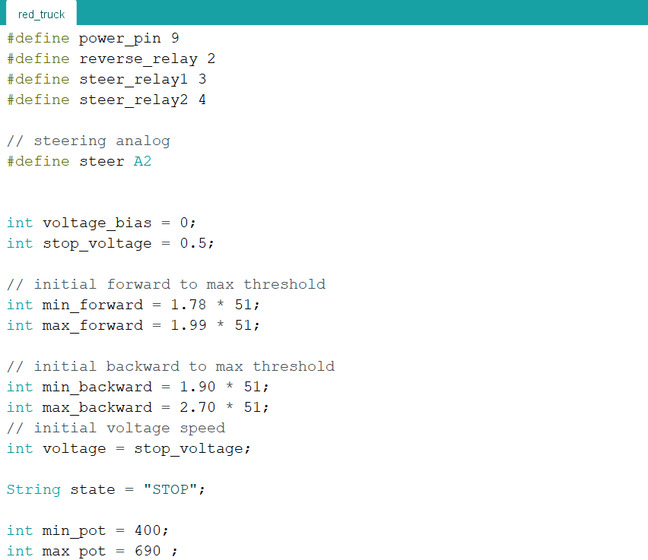

Figure : Arduino Code

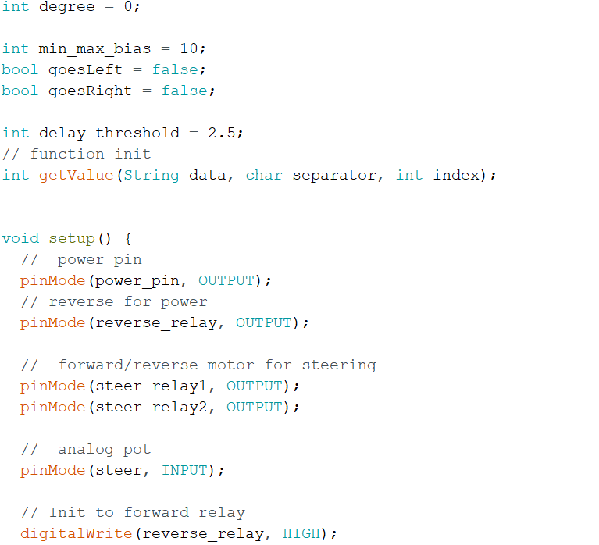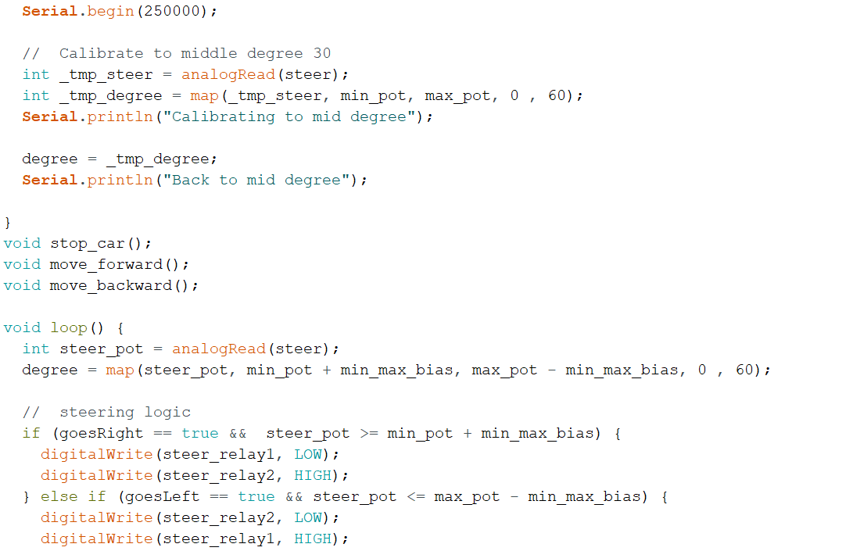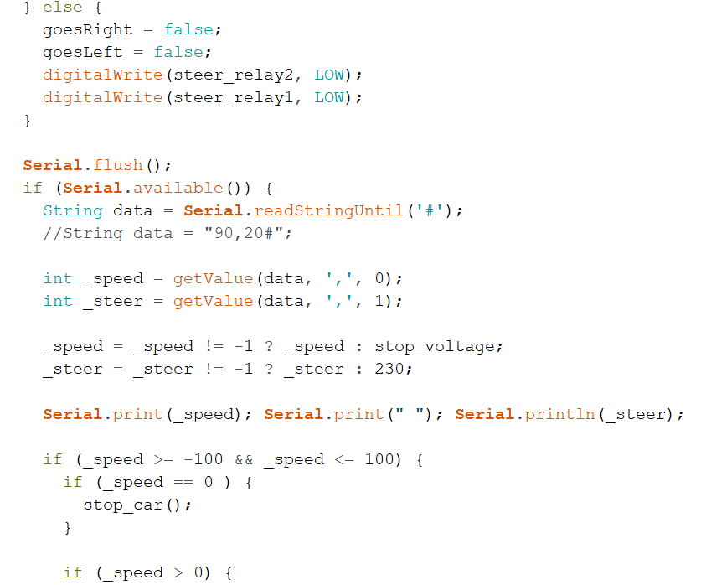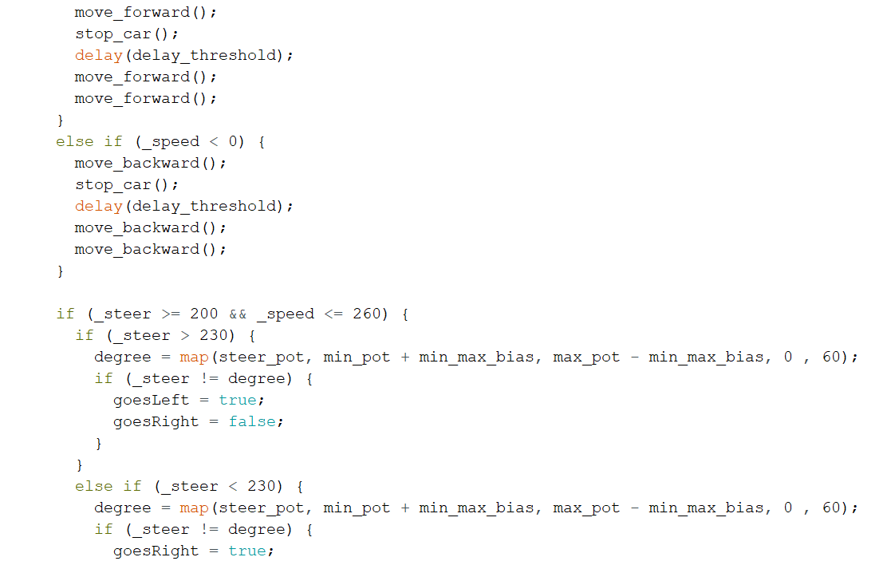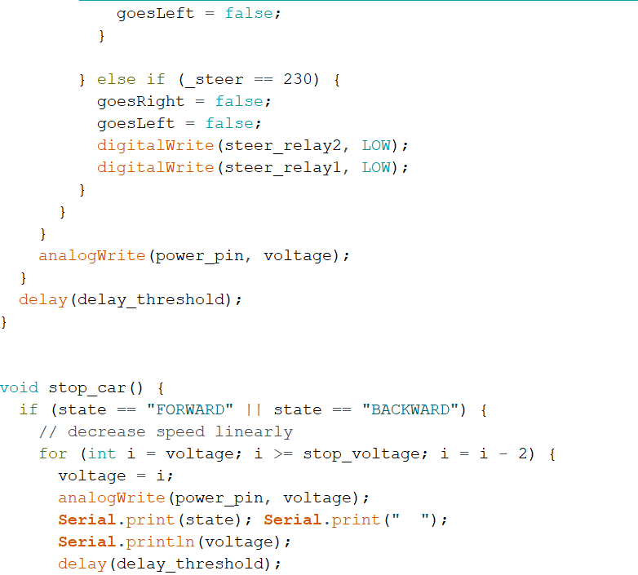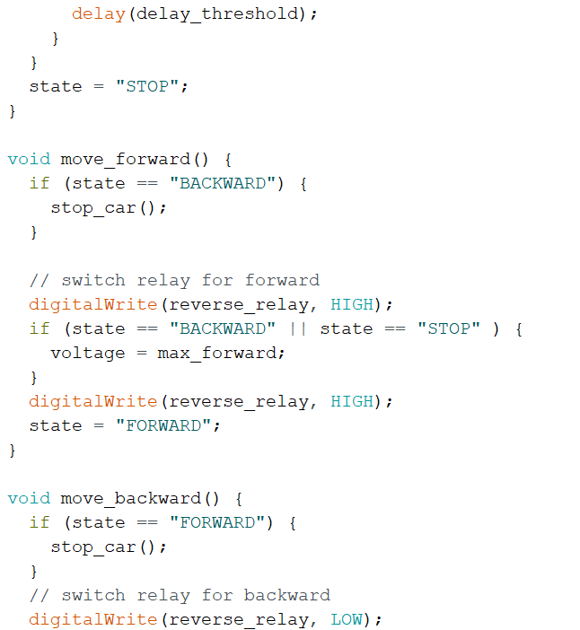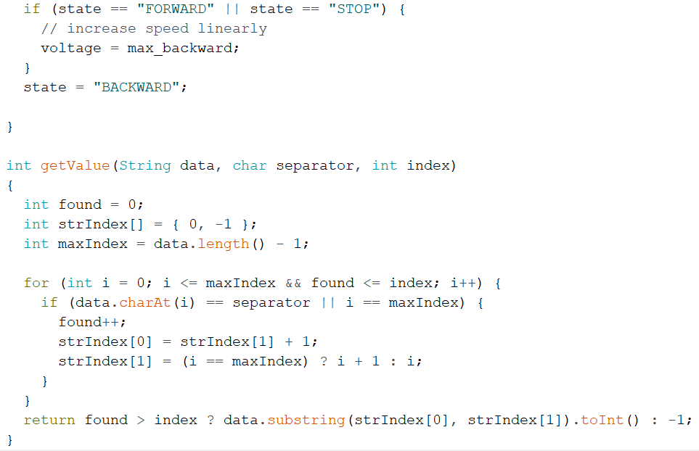

**Manual python source**

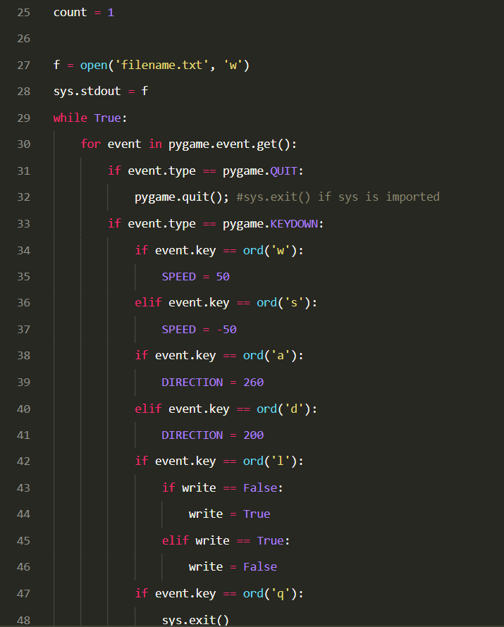

Figure : Manual Python source

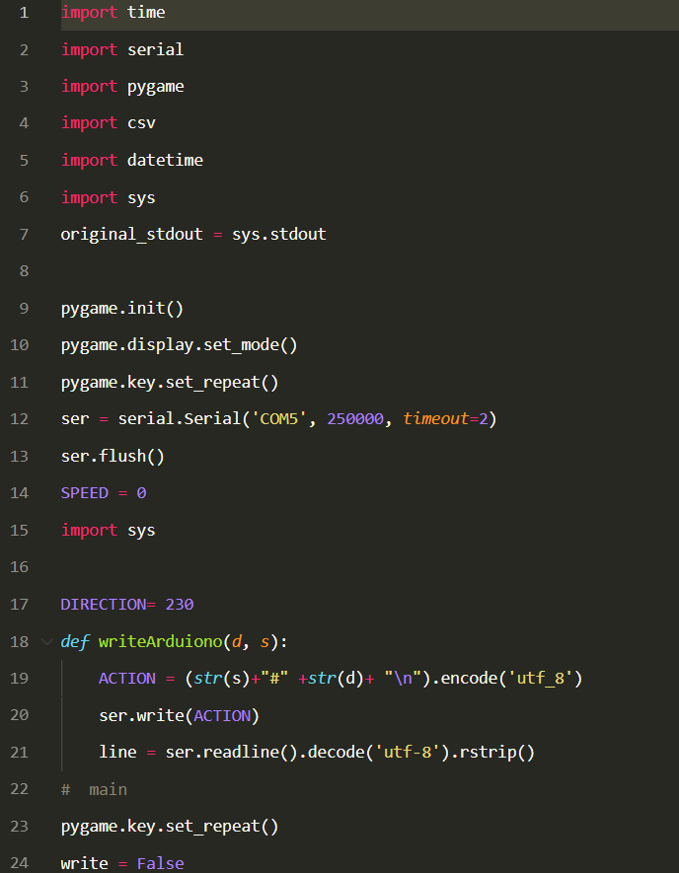

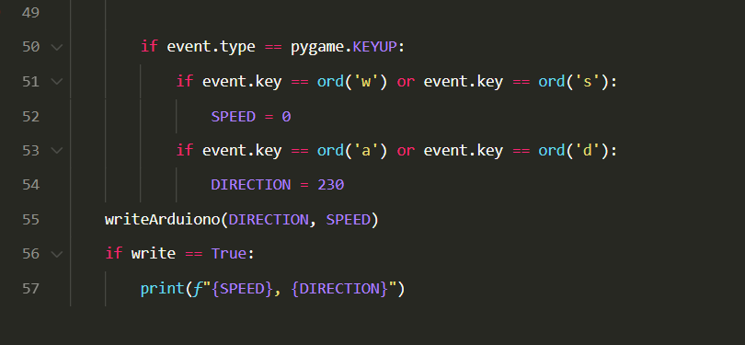

**Mimic Source Code**

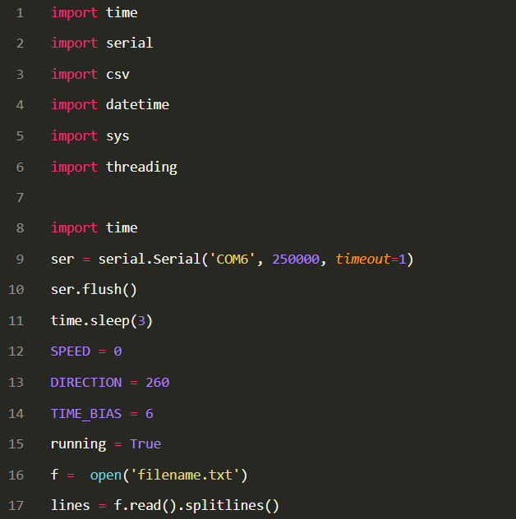

Figure : Behavioural Cloning code

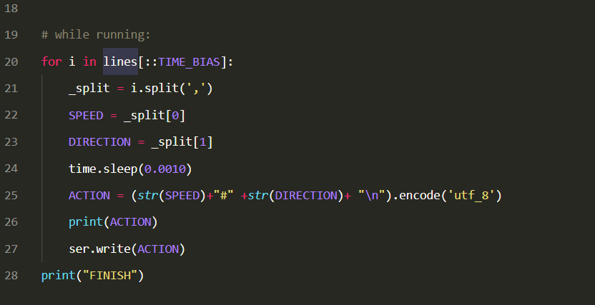

**AI Source Code**

